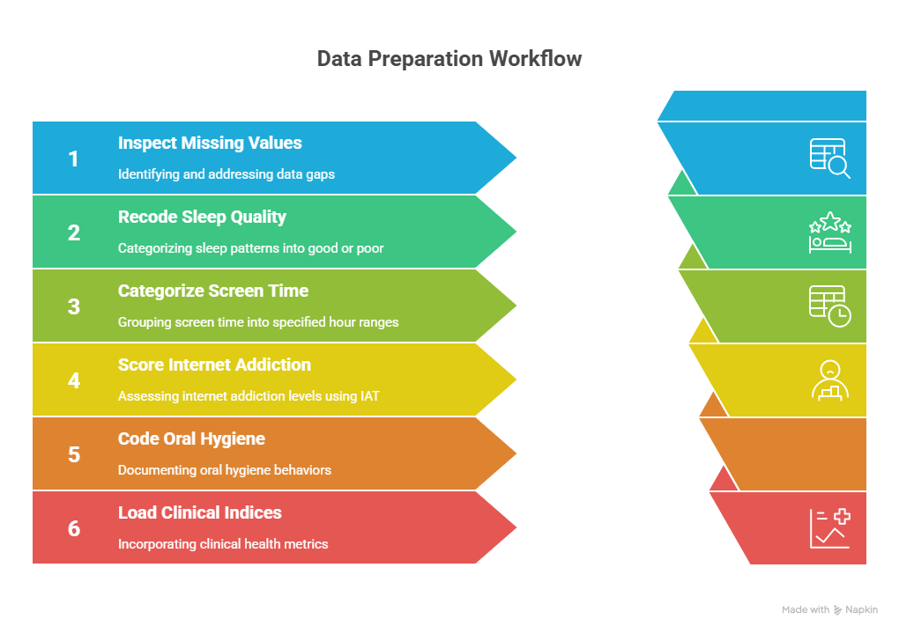

Figure 1. Variable Coding Flowchart) Data Preparation and Variable Coding Flowchart)

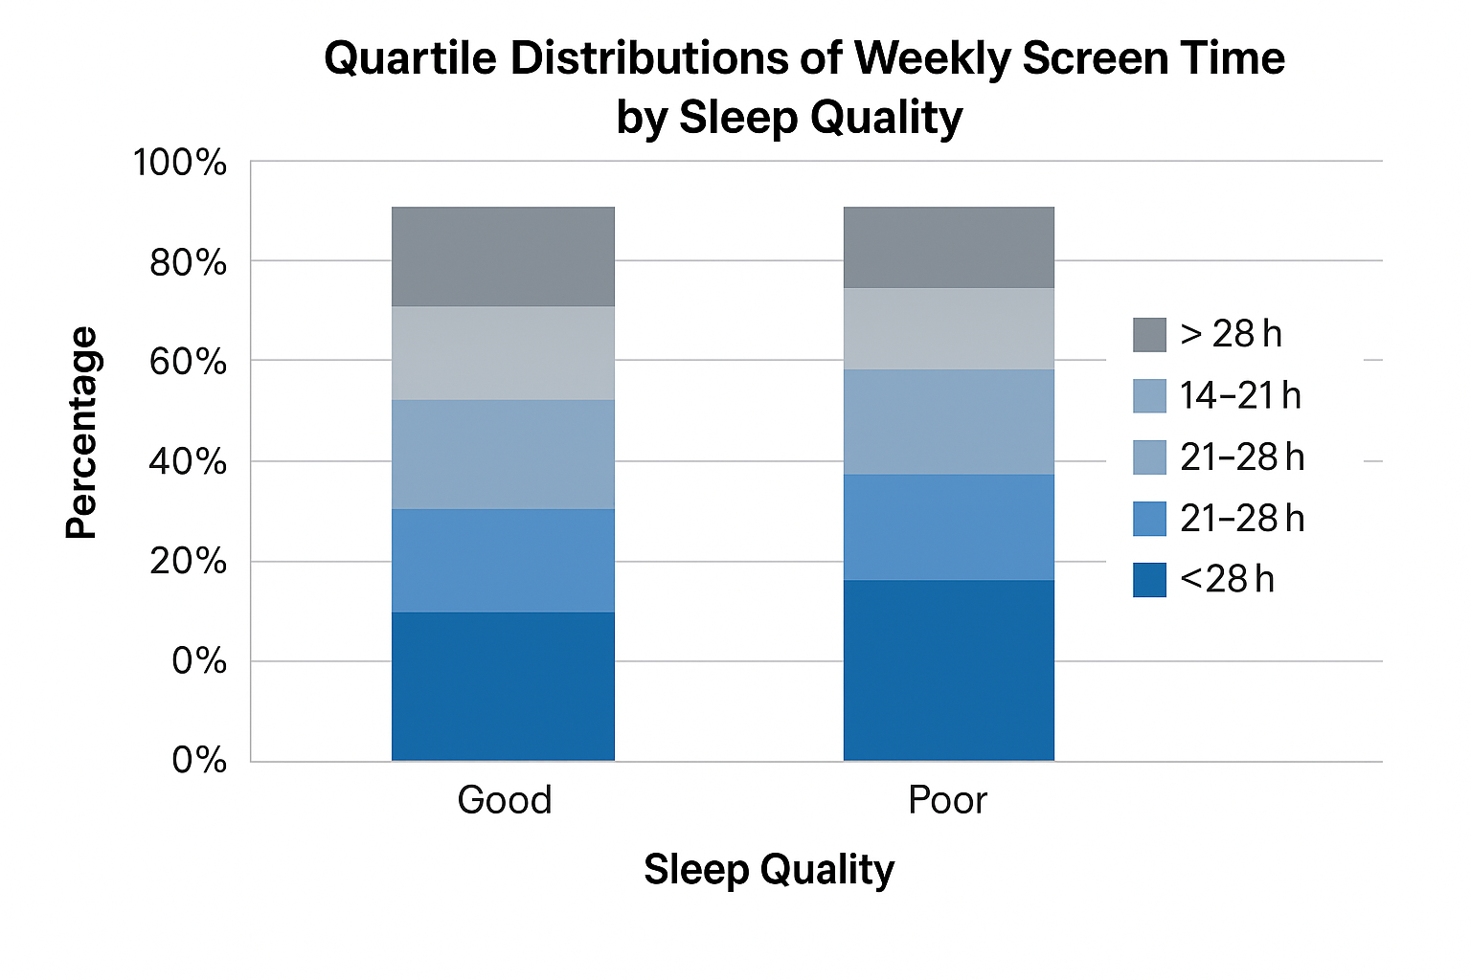

Figure 2. Behavioral and Clinical Variables) Correlation Matrix of Behavioral and Clinical Variables

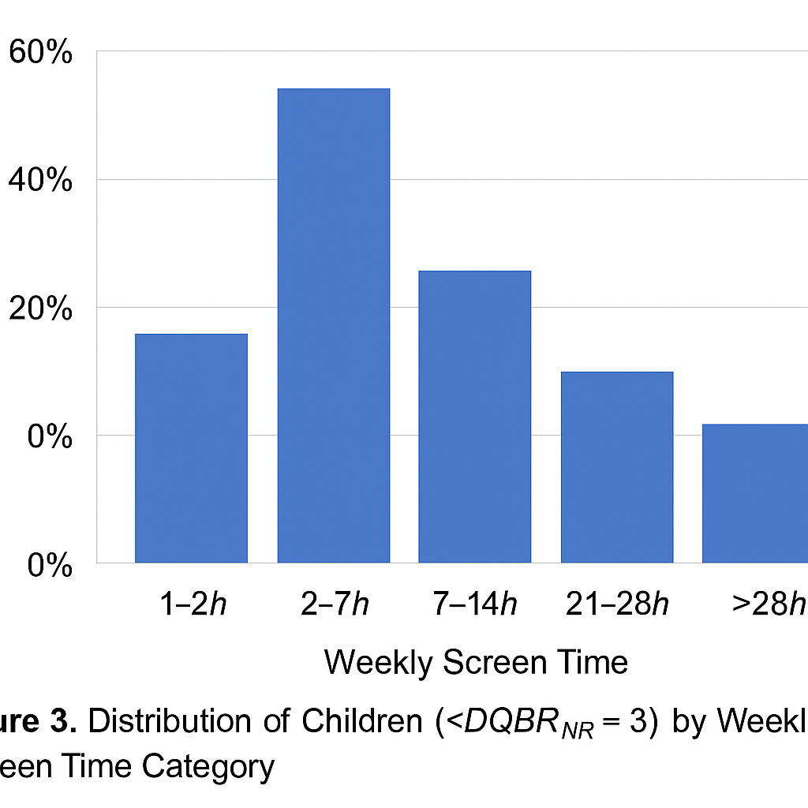

Figure 3 depicts the relationship between the quality of sleep and the time spent on the screen.  
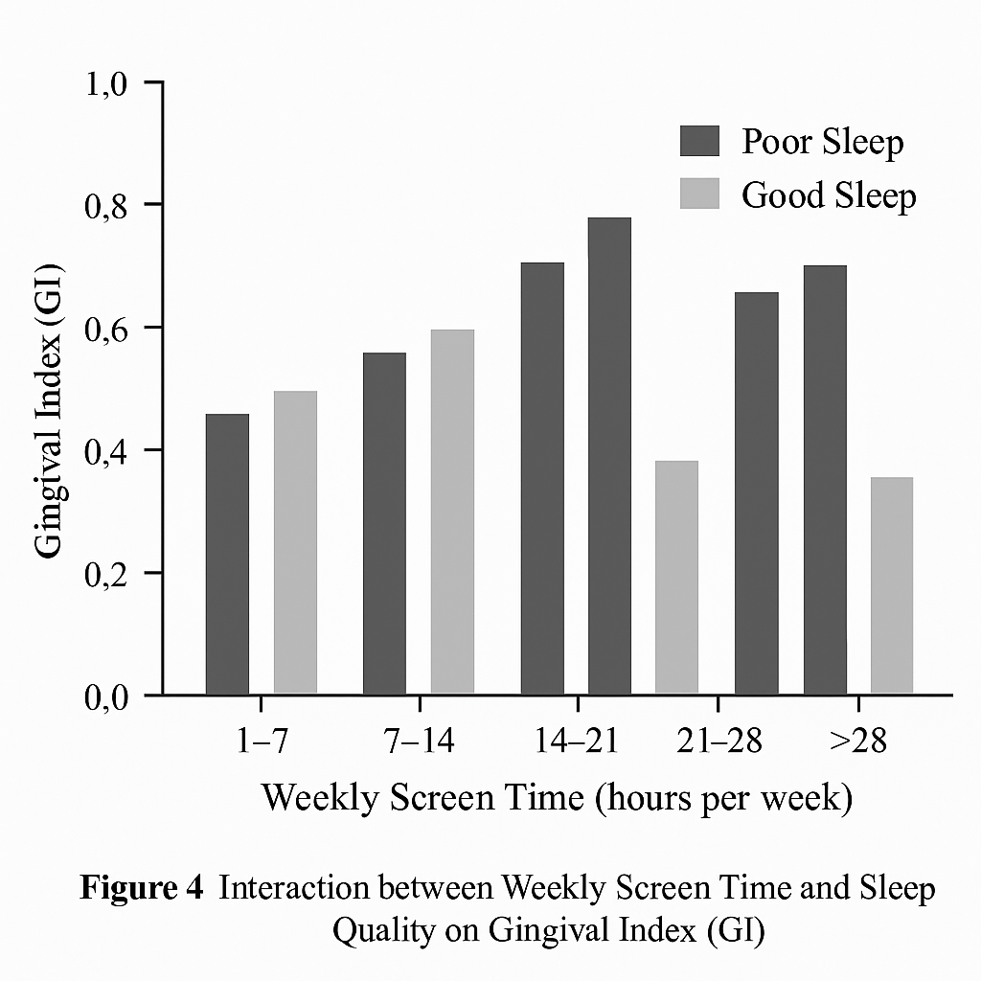

Figure 4. Sleep-Quality Groups Distribution.

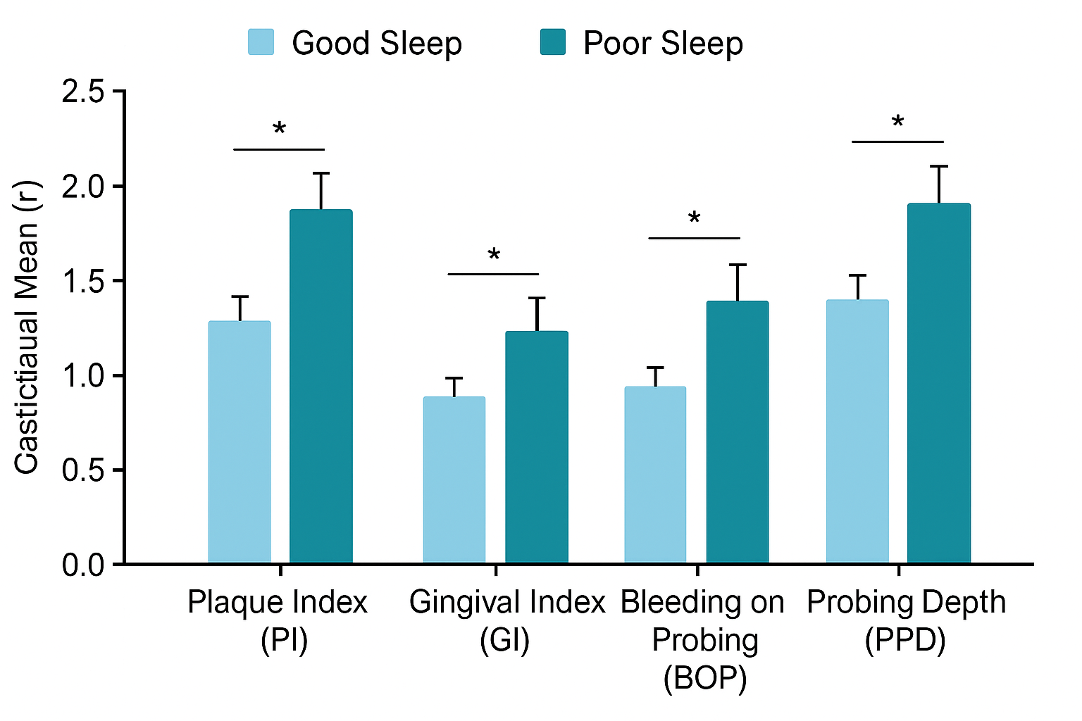

Figure 5. Weekly Distribution of Sleep Quality Screen-Time.

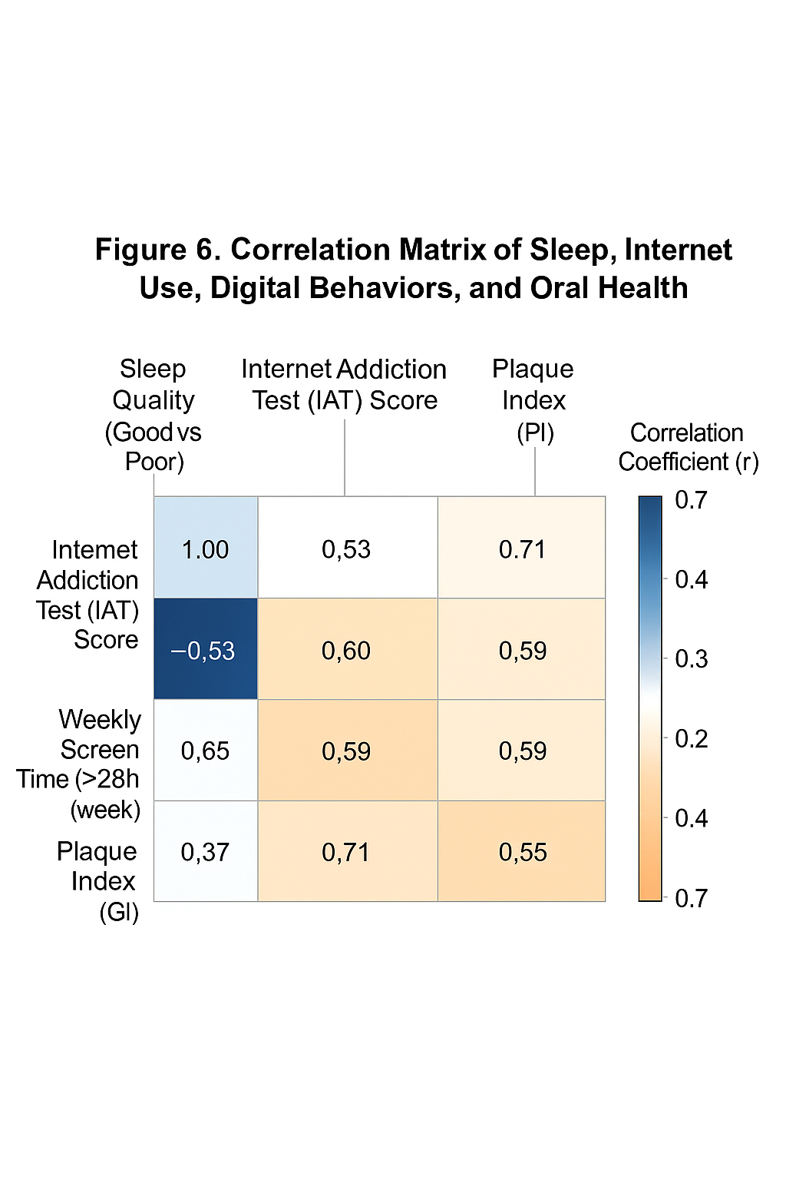

Figure 6. Boxplot of SLEEP-Quality GROUP of IAT Scores.

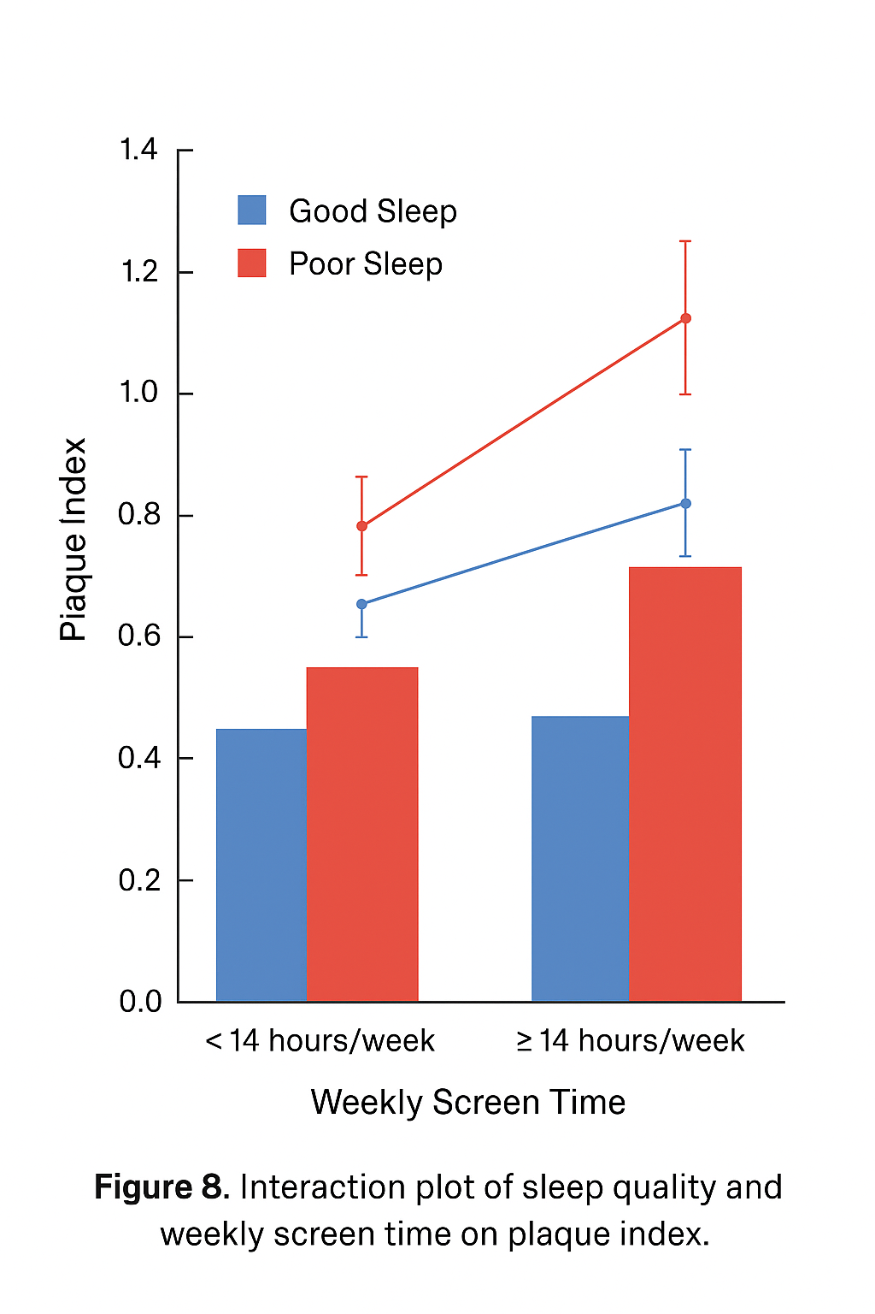

Figure 8. Screen Time Sleep Quality x Sleep Quality x Gingival Inflammation.